Key Learning Objectives
- Six Basic Sentence Patterns
- Adverbials
- Basic Diagramming

Test Sections
Multiple Choice: 28 points
- 14 questions at 2 points each
- 20 minutes

Sentence Revision 18 points
- 6 questions at 3 points each
- 10 minutes

Sentence Patterns – Label and Diagram: 30 points
- 3 diagrams at 10 points each
- 15 minutes

Coordination and Subordination: 24 points
- 4 questions at 6 points each
- 15 minutes

Bonus: Sentence Creation: 10 points
- 5 Questions at 2 points each
- 10 minutes

Section A: Multiple Choice
Question One: Which of the following sentence patterns best describes the sentence below? (2 pts)
Answer:_____
Sentence: Curiously, the white rabbit was always late.
- Linking Verb with a Subject Complement (Noun Phrase)
- Copular Be with a Subject Complement (Adjective Phrase)
- Ditransitive Verb with a Direct Object and an Object Complement (Noun Phrase)
- Intransitive Verb

Question Two: Which of the answers below is serving as an Optional Adverbial in this sentence? (2 pts)
Answer:_____________
Sentence: Typically, my neighbor brings me Christmas treats.
- “my neighbor”
- “me”
- “Typically”
- ‘Christmas treats”

Question Three: Which of the answers below is serving as a Subject Complement in this sentence? (2 pts)
Answer:_____________
Sentence: All my efforts were a waste of time after all.
- “All my efforts”
- “were”
- “a waste of time”
- “after all”

Question Four: What type of phrase listed below best describes the Object Complement in this sentence? (2 pts)
Answer:_____________
Sentence: All my friends called me ridiculous for my Halloween costume.
- Noun Phrase
- Adjective Phrase
- Prepositional Phrase
- Adverb Phrase

Question Five: What type of phrase below best describes the Subject Complement in this sentence? (2 pts)
Answer:_____________
Sentence: Some professors are also digital influencers
- Adverb Phrase
- Prepositional Phrase
- Adjective Phrase
- Noun Phrase

Question Six: Which of these is a Compound sentence containing two independent clauses? (2 pts)
Answer:
- Plumbers keep your pipes running smoothly and take pride in their work.
- They can install a sink, clear a drain, or replace your water heater.
- They always turn off the water before any project, and water pressure is carefully tested afterwards.
- If they do happen to flood they house, they always compensate you for the damage.

Question Seven: Which of these sentences is punctuated correctly (following the strictest prescriptive rules)?
Answer:
- You cannot enter this restaurant, if you are not wearing shoes.
- Allowing bare feet is unsanitary and the health department does not allow it.
- Since you have no shoes, I must ask you to leave.
- I am sorry; but that is our policy.

Part B. Sentence Revision
Question Eight:
Combine the two sentences below by adding a coordinating conjunction to form a compound sentence. Be sure to punctuate the new sentence correctly.
Many animals can understand sounds and signals. No animal so far is capable of mastering syntax.
- Many animals can understand sounds and signals, but no animal so far is capable of mastering syntax.

Question Nine:
Revise this sentence so that it follows the most formal prescriptive punctuation rules.
The guy with a terrible headache, and his sister waited for hours in the waiting room, because the hospital is severely understaffed.
The guy with a terrible headache and his sister waited for hours in the waiting room because the hospital is severely understaffed.

Question Ten:
Revise this sentence so that it is ditransitive with an indirect object and a direct object.
Tommy gave chocolates to his boyfriend.
- Tommy gave his boyfriend chocolates.

Part C: Sentence Patterns: Labeling and Diagramming – 10 pts each
Instructions: For each sentence below, take three steps
- Label the words, phrases, and roles
- Answer the question below the sentence
- Draw a tree diagram as we have practiced in class.

I have provided five empty pages in the back of the exam if you need them for corrections or practice. Please just clearly indicate which is your final answer!
Key
Parts of Speech  - Noun = N  - Verb = V  - Adjective = Adj  - Adverb = Adv  - Determiner = Det  - Preposition = Prep  - Pronoun = Pro  - Interjection = Intj  - Conjunction = Conj  - Relativizer = Rel  - Complementizer = Comp  Phrase Types  - Noun Phrase = NP  - Verb Phrase = VP  - Adjective Phrase = ADJP  - Adverb Phrase = ADVP  - Prepositional Phrase = PP | Roles  - Subject = Subj  - Predicate = Pred  - Adverbial = Advl  - Subject Complement = SC  - Direct Object = DO  - Indirect Object = IO  - Object Complement = OC  Clauses  - Sentence = S  - Independent Clause = IC  - Dependent Clause = DC  - Relative Clause = RC  - Complement Clause = CC  Sentence Patterns  - Copular Be  - Linking Verb  - Intransitive  - Transitive  - Ditransitive with Direct Object and Indirect Object  - Ditransitive with Direct Object and Object Complement

Question Eleven: Under pressure, she feels very confident in her skills.
ROLE | Adverbial |  | Subj | Pred | Subject Complement
PHRASE | PP |  | NP | VP | ADJP
WORD | Under | pressure | she | feels | very | confident | in | her | skills
Part of Speech | Prep | N | Pro | V | Adv | Adj | Prep | Det | N
Question: What sentence pattern is this sentence?_Linking Verb
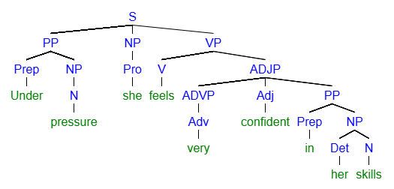
[S [PP [Prep Under] [NP [N pressure]]] [NP [Pro she]] [VP [V feels] [ADJP [ADVP [Adv very]] [Adj confident] [PP [Prep in] [NP [Det her] [N skills]
Question Twelve: Sentence: Obviously, I sent Larry the money!
ROLE | Adverbial | Subj | Pred | Indirect Object | Direct Object
PHRASE | ADVP | NP | VP | NP | NP
WORD | Obviously | I | sent | Larry | the | money
Part of Speech | Adv | Pro | V | N | Det | N
Question: What sentence pattern is this sentence? Ditransitive with Direct Object and Indirect Object
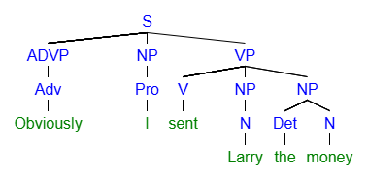
[S [ADVP [Adv Obviously]] [NP [Pro I]] [VP [V sent] [NP [N Larry]] [NP [Det the] [N money]
Question Thirteen: My dad called me quite foolish after my wreck.
ROLE | Subject |  | Predicate | Direct Object | Object Complement |  | Adverbial
PHRASE | NP |  | VP | NP | ADJP |  | PP
 | My | dad | called | me | quite | foolish | after | my | wreck
 | Det | N | V | Pro | Adv | Adj | Prep | Det | N
Question: What sentence pattern is this sentence? Ditransitive with a Direct Object and Object Complement
Good = Full points
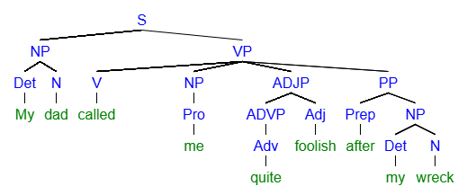
Better = Full points
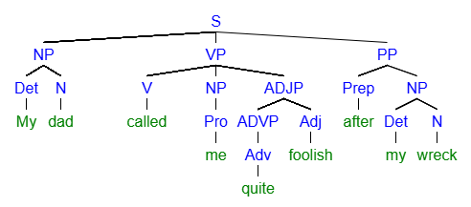
[S [NP [Det My] [N dad]] [VP [V called] [NP [Pro me]] [ADJP [ADVP [Adv quite]] [Adj foolish]]] [PP [Prep after] [NP [Det my] [N wreck]
Part D: Coordination and Subordination: Sentence Diagrams: 30 points (5 diagrams, 8 points each)
- Label the sentence as Simple, Compound, or Complex
  - Simple = One clause with conjoined phrases
  - Compound = Two independent clauses with a coordinating conjunction
  - Complex = One independent clause and one dependent clause with a subordinating conjunction

- Complete a diagram in the style we have been practicing.

- If the sentence has multiple clauses, please label the separate clauses as
  - Independent Clause - S(IC)
  - Dependent Clause – S(DC)

I have provided five empty pages in the back of the exam if you need them for corrections or practice. Please just clearly indicate which is your final answer!

Question Fourteen: Since I enjoy the outdoors, I recently rode a snowmobile for the first time.
- Question: Is this sentence Complex, Compound, or Simple

Good = Full points
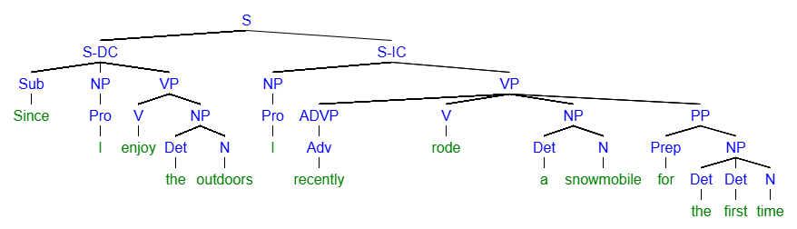
Better = Full points
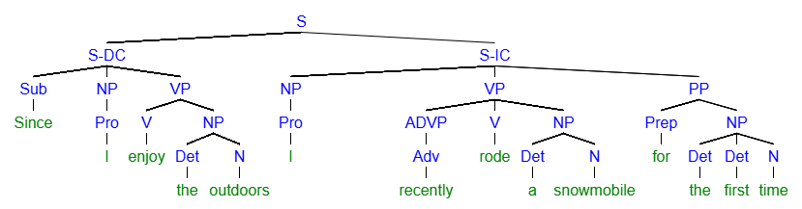
[S [S-DC [Sub Since] [NP [Pro I]] [VP [V enjoy] [NP [Det the] [N outdoors]]]] [S-IC [NP [Pro I]] [VP [ADVP [Adv recently]] [V rode] [NP [Det a] [N snowmobile]]] [PP [Prep for] [NP [Det the] [Det first] [N time]
Question Fifteen: The man with many hats and the boy on the trampoline went to school.. (10 pts)
- Question: Is this sentence Complex, Compound, or Simple?
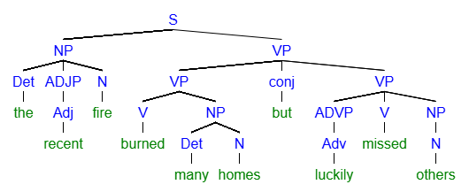
[S [NP [Det the] [ADJP [Adj recent]] [N fire]] [VP [VP [V burned] [NP [Det many] [N homes]]] [conj but] [VP [ADVP [Adv luckily]] [V missed] [NP [N others]
Question Sixteen: I helped the man and woman in trouble, or I offered them some assistance at least. (10)
- Question: Is this sentence Complex, Compound, or Simple
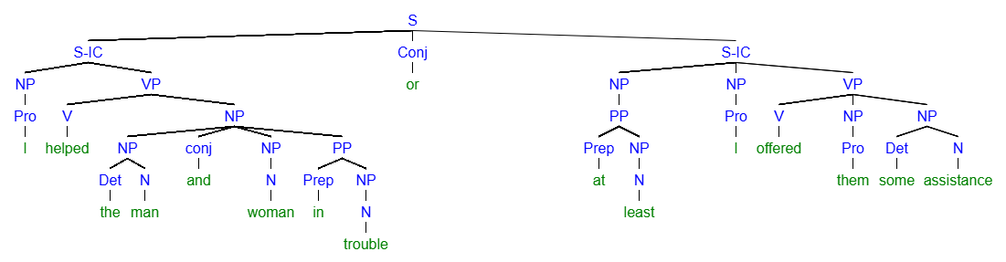

When John fell down, I ate, and Bob drank.
Coordinating – For, And, Nor, But, Or, Yet, So
Subordinating – Because, When, If, Although, While,
- Shruti cried, but Rin screamed while Ali and Jessa celebrated.
- If the cat is hungry, I will feed him or give him a treat.
- Josh ate bugs, and Bugs ate his friend while Jerry tickled a mouse.
- If you are hungry, you should eat, or you could drink something.
- I fell down the stairs, and Phil laughed, when the clock struck twelve, and the stairs cracked.
Section E: Sentence Creation - Bonus
For section D and the Bonus, please write all the new sentences about a movie, book, or TV show you like. Feel free to reuse the same ideas and characters from the movie, book, or TV show as many times as you like.
I will ask you to please chose a DIFFERENT movie, book, or TV show for the actual essay.
Name the movie, book, or TV show here:________________________________________________________________________
Question Sixteen: (2 pts bonus)
Write a sentence containing a Noun Phrase Serving as an Object Complement
- Charlie Sheen is a winner.

Question Seventeen: (2 pts bonus)
Write a sentence containing a Prepositional Phrase serving as an Adverbial at the beginning of the sentence.
- In that show, Ashton Kucher was just not a good replacement.

Question Eighteen: (2 pts bonus)
Write a sentence with Three Conjoined Noun Phrases as the Subject.
- Martin, Charlie, and Emilio all had careers in acting, but I prefer Martin.

